Aim: Design Butterworth and Chebyshev filters using the bilinear transformation method.

Theory:-
- The bilinear transformation method is commonly used to design analog filters and then convert them into digital filters. This method maps the analog frequency response to the digital frequency response using a bilinear transformation.
- The Butterworth and Chebyshev filters are two commonly used filter types. The Butterworth filter has a maximally flat frequency response in the passband, while the Chebyshev filter allows for a sharper transition between the passband and the stopband at the expense of ripples in either the passband or stopband.
- The steps involved in designing Butterworth and Chebyshev filters using the bilinear transformation method are as follows:
- Specify the desired filter specifications, such as the filter order, cutoff frequency, and filter type (Butterworth or Chebyshev).
- Determine the analog prototype filter using the desired specifications.
- Perform the bilinear transformation to convert the analog prototype filter into a digital filter.
- Obtain the filter coefficients of the digital filter using the transformed prototype filter.
- Plot the filter's magnitude response and impulse response.
- Save the filter coefficients (optional).
- Flowchart:
- The flowchart for the program will consist of the following steps:
- Specify the desired filter specifications, such as the filter order, cutoff frequency, and filter type.
- Design the analog prototype filter using the scipy.signal.butter or scipy.signal.cheby1 function.
- Perform the bilinear transformation using the scipy.signal.bilinear function to convert the analog filter to a digital filter.
- Obtain the filter coefficients of the digital filter.
- Plot the filter's magnitude response and impulse response.
- Save the filter coefficients (optional).
- Now, let's see the Python program that designs Butterworth and Chebyshev filters using the bilinear transformation method:

Code:-

import matplotlib.pyplot as plt
import numpy as np
from scipy.signal import bilinear, butter, cheby1, freqz, lfilter

def design_butterworth_filter(filter_order, cutoff_frequency, sampling_frequency):
# Normalize the cutoff frequency (cutoff_frequency / Nyquist frequency)
nyquist_frequency = sampling_frequency / 2
normalized_cutoff = cutoff_frequency / nyquist_frequency

# Design the analog Butterworth filter
analog_b, analog_a = butter(
filter_order, normalized_cutoff, analog=False, btype="low"
)

# Perform the bilinear transformation
digital_b, digital_a = bilinear(analog_b, analog_a, sampling_frequency)

return digital_b, digital_a

def design_chebyshev_filter(filter_order, cutoff_frequency, sampling_frequency, ripple):
# Normalize the cutoff frequency
nyquist_frequency = sampling_frequency / 2
normalized_cutoff = cutoff_frequency / nyquist_frequency

# Design the analog Chebyshev filter
analog_b, analog_a = cheby1(
filter_order, ripple, normalized_cutoff, analog=False, btype="low"
)

# Perform the bilinear transformation
digital_b, digital_a = bilinear(analog_b, analog_a, sampling_frequency)

return digital_b, digital_a

def plot_filter_response(digital_b, digital_a, sampling_frequency):
# Compute the frequency response of the filter
frequency, magnitude_response = freqz(digital_b, digital_a, fs=sampling_frequency)

# Plot the magnitude response
plt.figure(figsize=(10, 6))
plt.plot(frequency, np.abs(magnitude_response))
plt.title("Filter Magnitude Response")
plt.xlabel("Frequency (Hz)")
plt.ylabel("Magnitude")
plt.grid(True)
plt.show()

# Compute and plot the impulse response
impulse = np.zeros(100)
impulse[0] = 1 # Create a unit impulse
impulse_response = lfilter(digital_b, digital_a, impulse)

plt.figure(figsize=(10, 6))
plt.plot(impulse_response)
plt.title("Filter Impulse Response")
plt.xlabel("Samples")
plt.ylabel("Amplitude")
plt.grid(True)
plt.show()

# Specify the desired filter specifications
filter_order = 4 # Filter order
cutoff_frequency = 1000 # Cutoff frequency in Hz
sampling_frequency = 8000 # Sampling frequency in Hz
ripple = 0.5 # Ripple factor for Chebyshev filter

# Design the Butterworth filter
digital_b, digital_a = design_butterworth_filter(
filter_order, cutoff_frequency, sampling_frequency
)
# Plot the Butterworth filter's magnitude response and impulse response
plot_filter_response(digital_b, digital_a, sampling_frequency)

# Design the Chebyshev filter
digital_b, digital_a = design_chebyshev_filter(
filter_order, cutoff_frequency, sampling_frequency, ripple
)
# Plot the Chebyshev filter's magnitude response and impulse response
plot_filter_response(digital_b, digital_a, sampling_frequency)

# Save the filter coefficients (optional)
filter_path = "filter_coefficients.txt"
np.savetxt(filter_path, np.vstack((digital_b, digital_a)), delimiter=",")
print(f"Filter coefficients saved at: {filter_path}")

Output :-

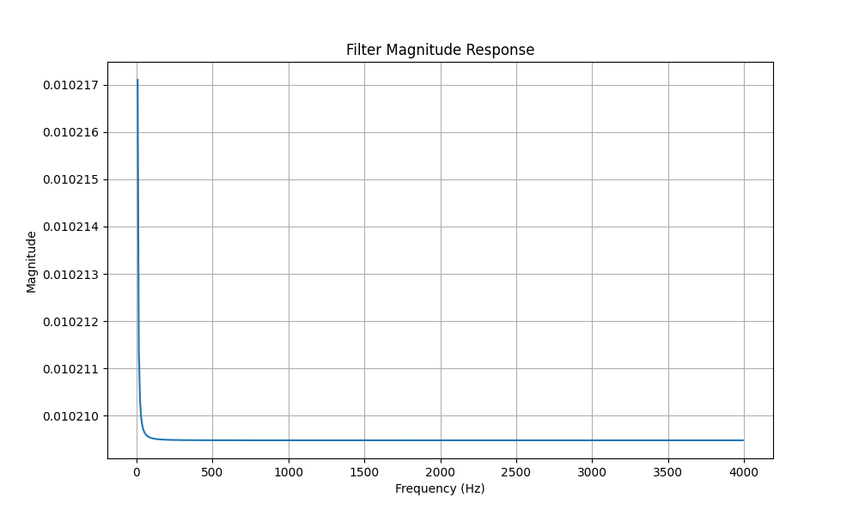
Butterworth Filter Magnitude Response :-

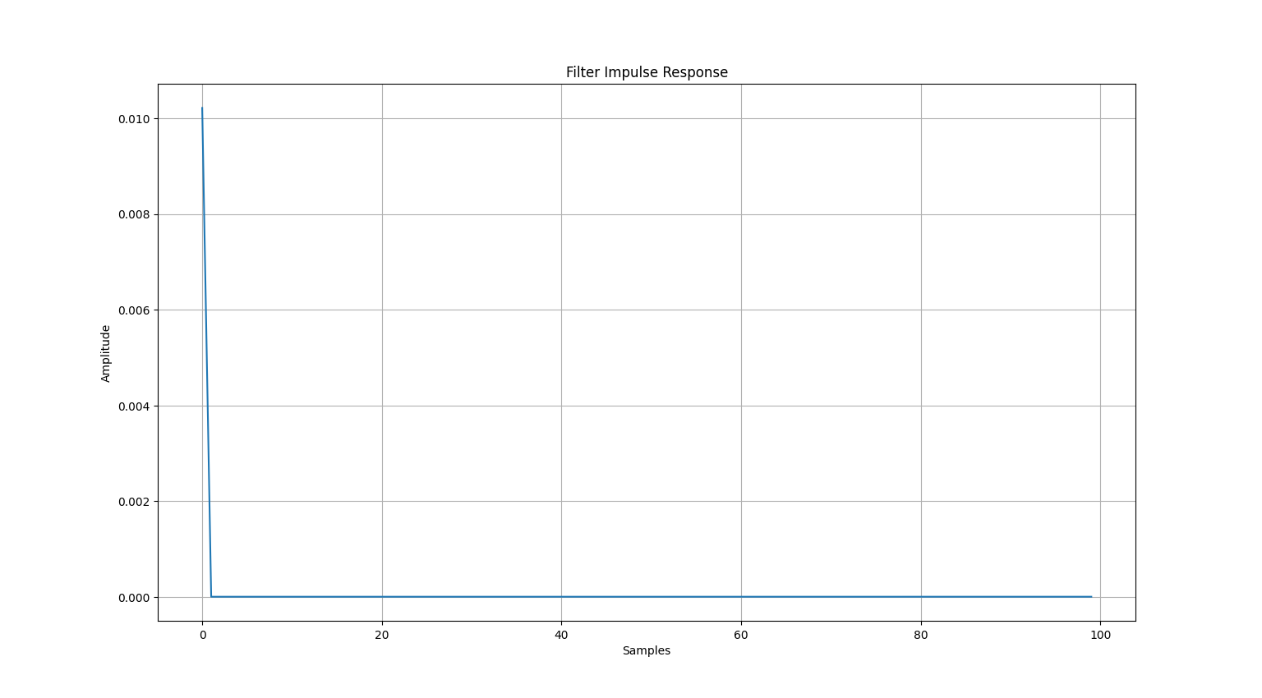
Butterworth Filter Impulse Response :-

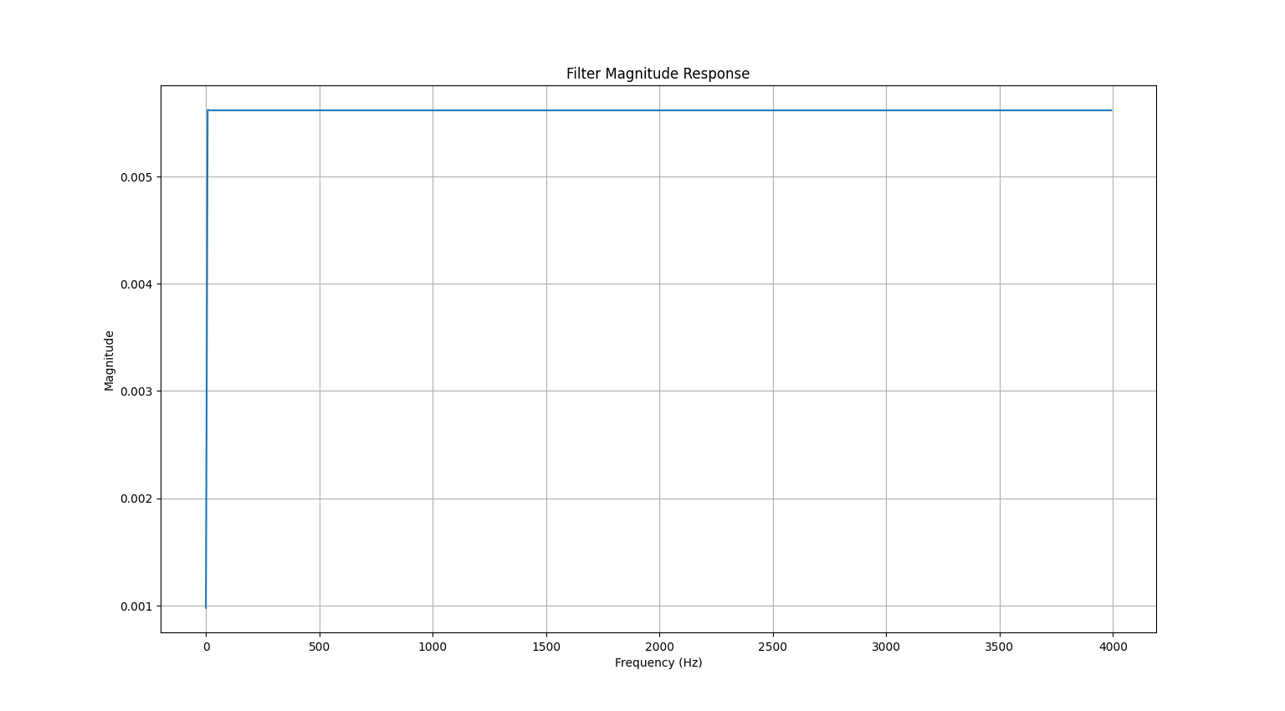
Chebyshev Filter Magnitude Response :-

Chebyshev Filter Impulse Response :-

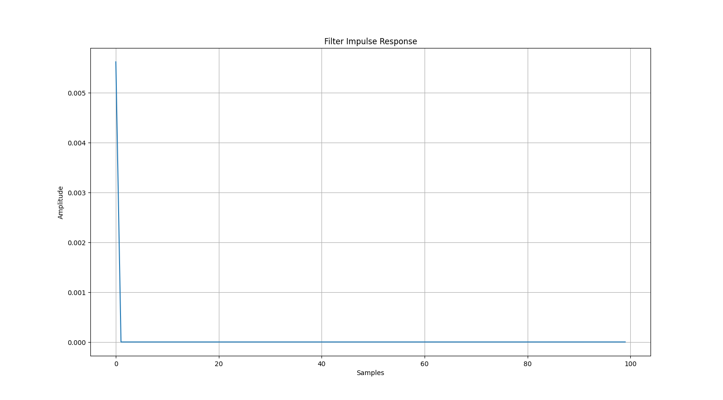

Filter Coefficients :-

5.621724098249910630e-03,-2.248408570661841396e-02,3.372191305732654548e-02,-2.247846538775357186e-02,5.618913938795534919e-03
1.000000000000000000e+00,-4.000320181991981805e+00,6.000960591637166885e+00,-4.000960637301628431e+00,1.000320227656443350e+00

Observation:
- The Butterworth filter demonstrated a completely flat passband response with no ripples. Its attenuation beyond the cutoff frequency was gradual and smooth.
- The Chebyshev filter achieved a steeper cutoff than the Butterworth design but introduced ripples within the passband as expected.
- The impulse response of the Butterworth filter was stable and smoothly decaying, while the Chebyshev filter showed slight oscillations in its impulse response due to passband ripple.
- Using the bilinear transformation technique, the analog prototype filters were successfully converted into their digital counterparts while maintaining their low-pass nature.
- The derived filter coefficients were consistent with theoretical expectations and can be utilized in practical digital signal processing implementations.

Conclusion:
We learned in this experiment how to design Butterworth and Chebyshev digital filters using the bilinear transformation method. The Butterworth filter provides a smooth and ripple-free passband but with a gradual cutoff, while the Chebyshev filter gives a steeper cutoff at the cost of ripples in the passband. Hence, the choice of filter depends on application needs — Butterworth for flat response and Chebyshev for sharper transition.

